**SOLUTIONS…**

**SET 1**

1. Create Employee table for the following details

|  |  |  |  |
| --- | --- | --- | --- |
| S.No | Name | Designation | Branch |
| 1 | Suresh | Manager | Chennai |
| 2 | Ramesh | Supervisor | Madurai |
| 3 | Hari | Assistant | Trichy |

Perform the following:

* Alter the table by adding a column **Salary**

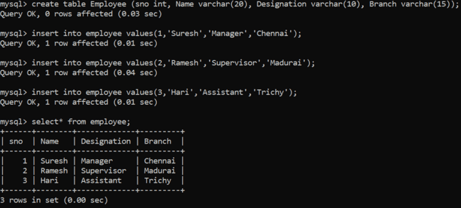

* Alter the table by modifying the column **Name**

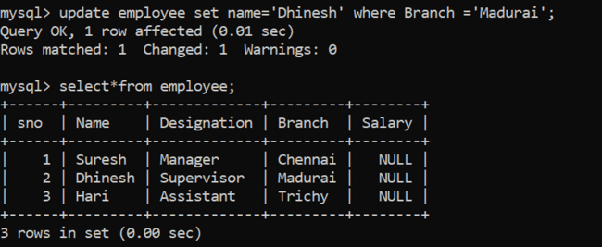

* Describe the table **employee and** Rename table **employee** as **emp**

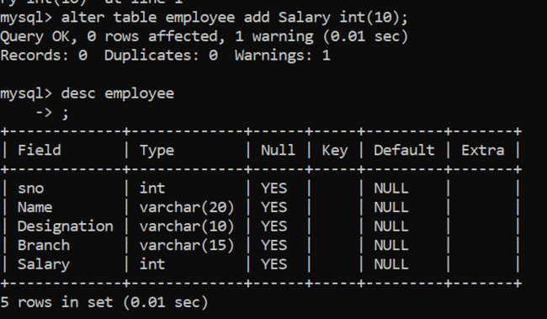

* Delete the Second row from the table

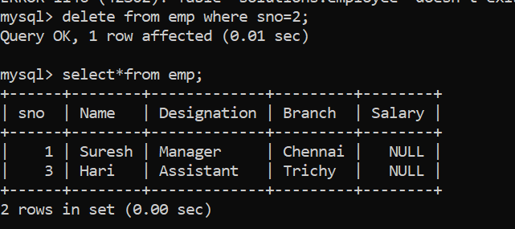

* Drop the table

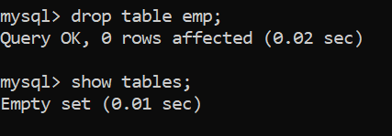

1. Write a function to build a string repeatedly until the value of the variable becomes greater than 5. Then, we display the final string using a SELECT statement

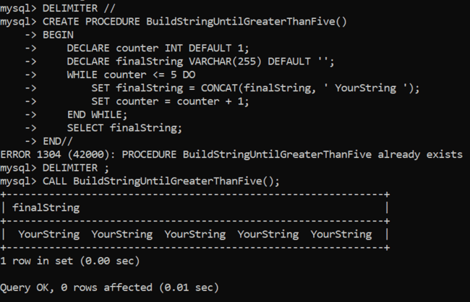

1. Create a recursive MySQL computing the factorial of a given number using high level programing Extension with **Functions.**

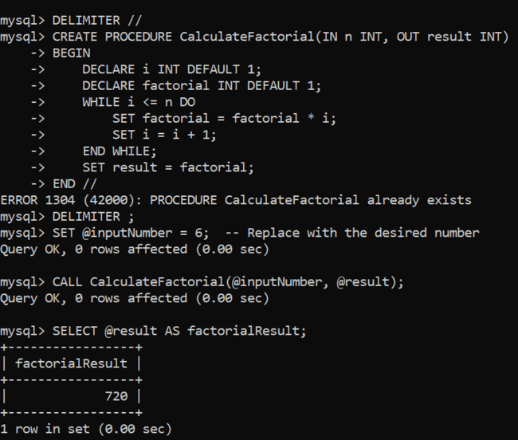

1. Create a simple **procedure** to get all the records from the table ‘Employee’ and List out the name, department, salary where salary > 20000 in the Table.

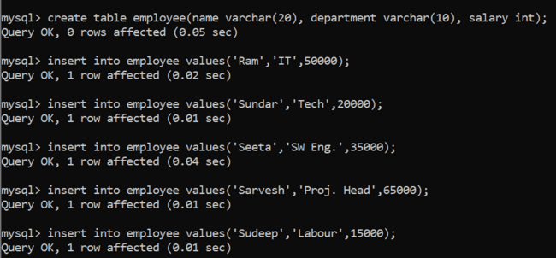

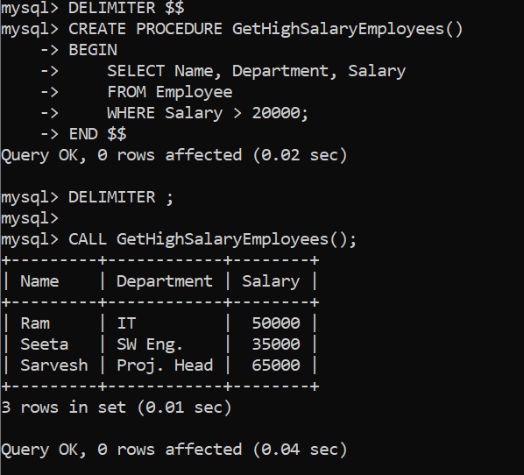

**SET 2**

1. Create a Table as **bank** and the details are

|  |  |  |  |  |
| --- | --- | --- | --- | --- |
| S.No | Cust_Name | Acc_no | Balance | Cus_Branch |
| 1 | Ramesh | 12378 | 100000 | Adyar |
| 2 | Sam | 12367 | 152500 | Mylapore |
| 3 | Harish | 12345 | 250000 | Anna Salai |

Perform the following:

* Simple Select

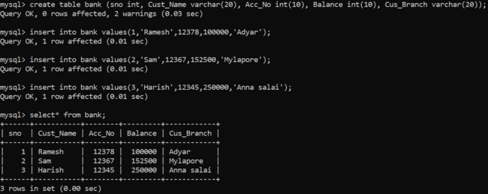

* Select with **where** clause

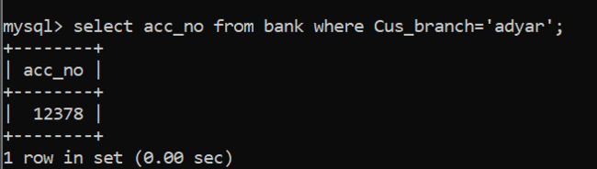

* Select with **comparison operator >**

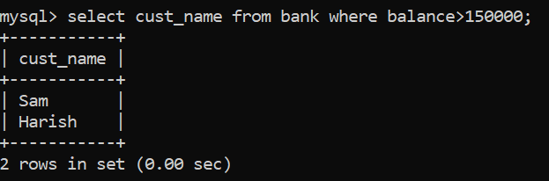

* Select with**between** in the field **Balance**

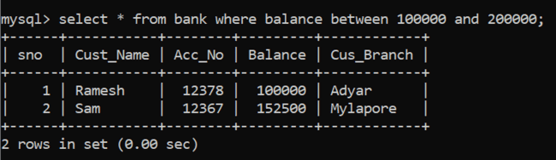

* Update the **Cus_Branch** in the second row as **Poonamallee**



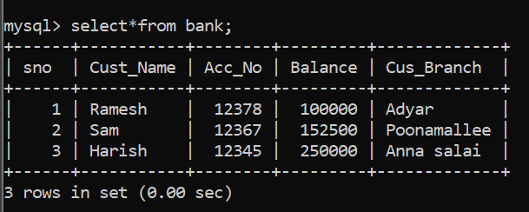

1. Write a program that uses CASE statement where if monthly_value is equal to 4000, then income_level will be set to 'Low Income'. If monthly_value is equal to 5000, then income_level will be set to 'Avg Income'. Otherwise, income_levelwill be set to 'High Income'.

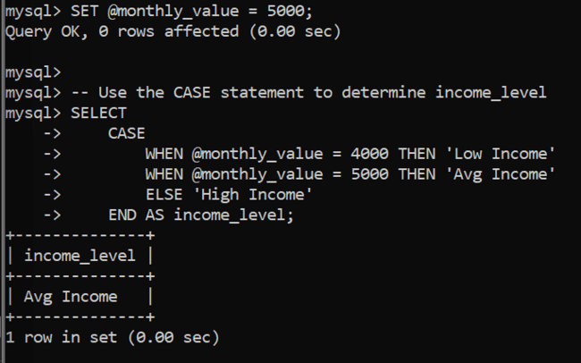

1. Create a trigger in MySQL to log the changes of the EMPLOYEES table with fields ID, Name and Email. Also create a new table named EMPLOYEES_AUDIT to keep the changes of the employee table. Create a BEFORE UPDATE trigger that is invoked before a change is made to the employees table.

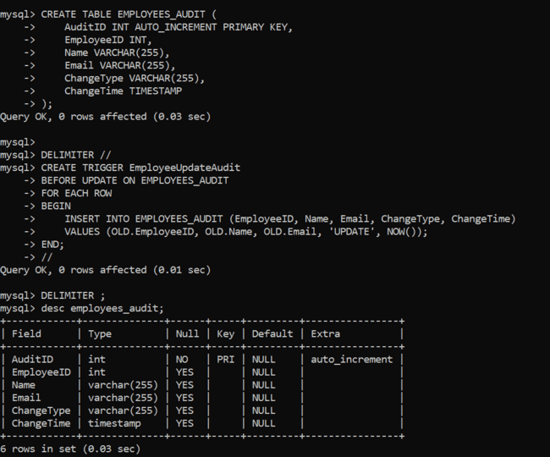

1. Write a procedure to display all the records form customer table.

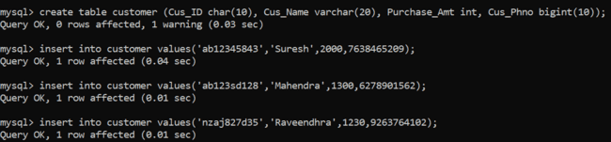

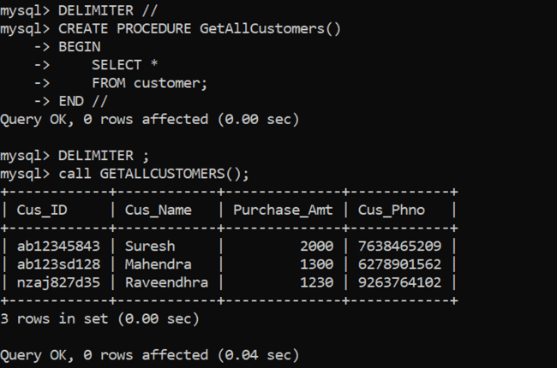

**SET 3**

1. Create a Table as **book** and the details are

|  |  |  |  |  |
| --- | --- | --- | --- | --- |
| S.No | B_Name | Author | Price | Publisher |
| 1 | DBMS | Seema Kedhar | 250 | Charulatha |
| 2 | TOC | John Martin | 400 | Tata McGraw Hill |
| 3 | C | Balagurusamy | 300 | Technical |

Perform the following:

* + Use **Select** keyword and display the table

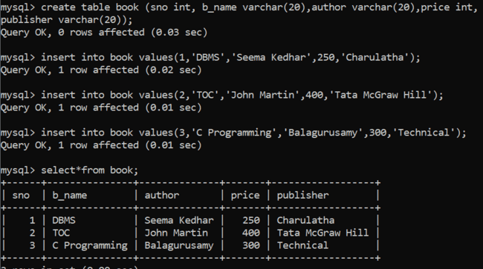

* + Display the book which is => 300

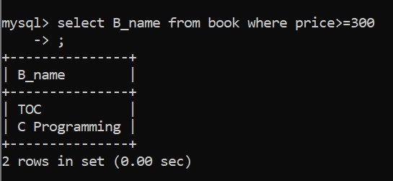

* + **Insert a** rowand add new book to the book table

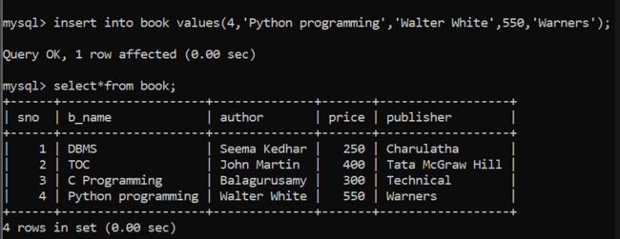

* + Drop **Author** column

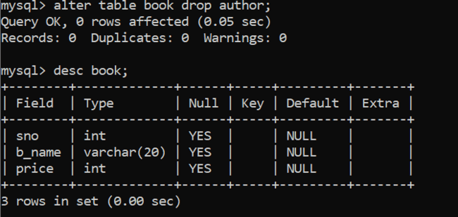

1. Write a function that uses REPEAT statement which would repeat the loop until income is greater than or equal to 4000, at which point the REPEAT loop would be terminated.

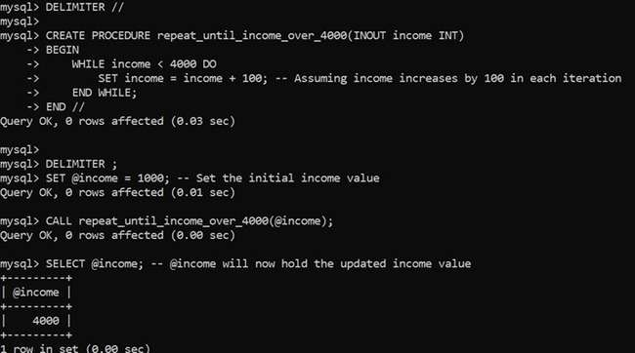

1. Write a function that uses CASE statement where if monthly_value is equal to or less than 4000, then income level set to ‘Low Income’. If monthly_value is equal to or less than 5000, then income_level will be set to 'Avg Income'. Otherwise, income_levelwill be set to 'High Income'.



1. Write a procedure to list all the employees working more than 20 year in a company.

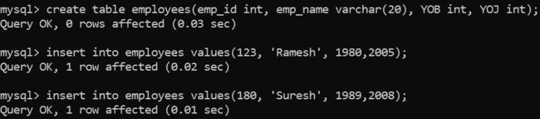

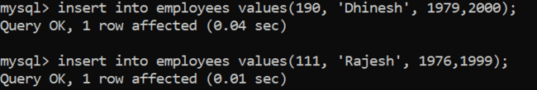

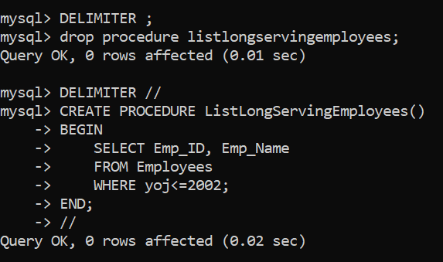

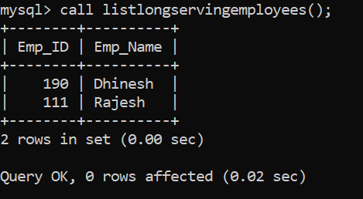

**SET -4**

**3.**

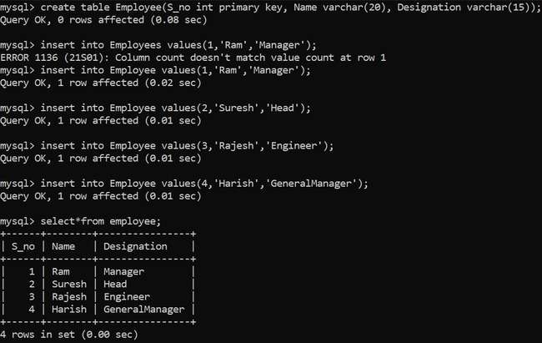

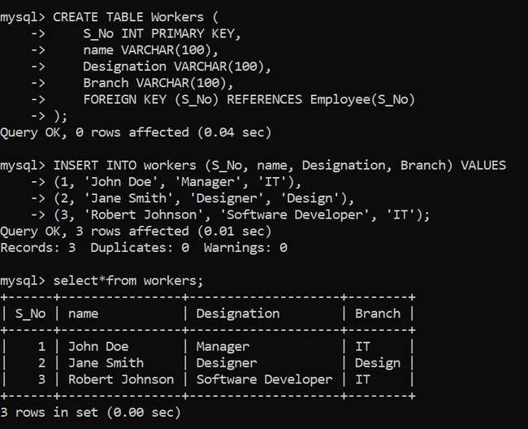

**Set -6**

**2.**

